

DAND Act Report

Omar Abdulaziz Alashikh

# Q1: What are the most Dog stages

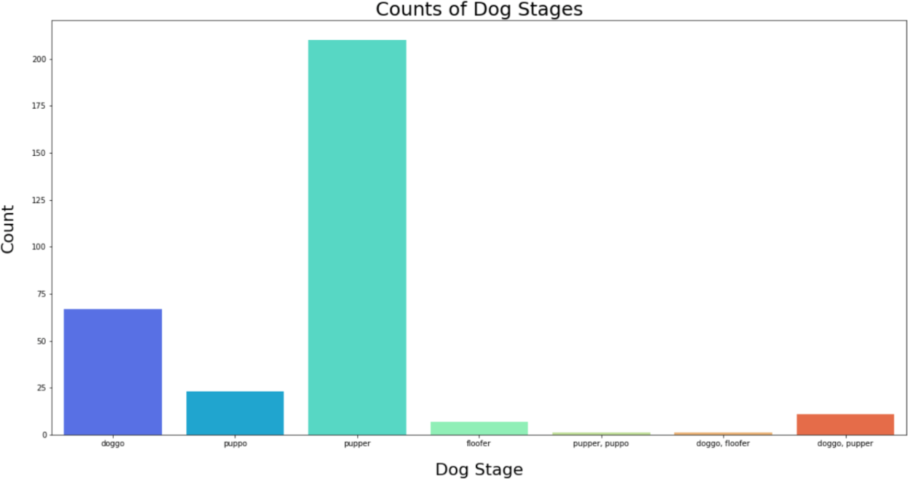

It’s the pupper breed

# Screen Shot 1443-02-13 at 4.30Q2: The Statics of source tweets

Twitter for iPhone users generates the most tweets.

# Q3: What is the Top 30 doggo names

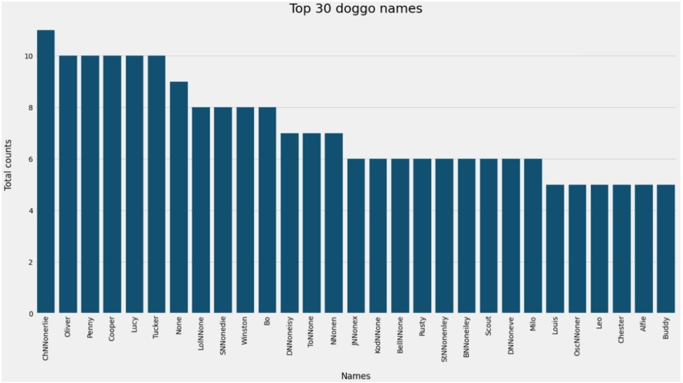

It’s not a static thing you can name your dog whatever you want

# WhatsApp Image 2021-09-20 at 6.31Q4: What are the most popular dog breeds

# f

# the most popular dog breed is the golden Retriever